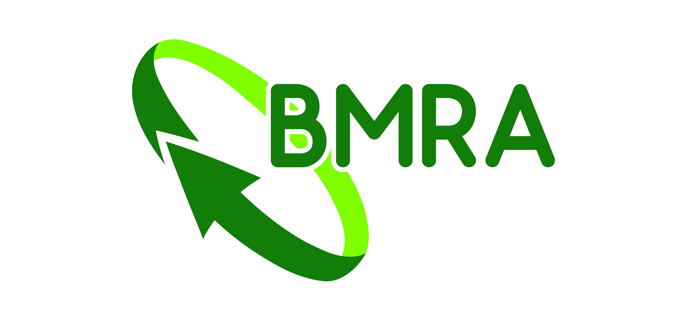

Equipment listing

Company | * |  | Contact | *
Tel no: |  | *
Email | *

Please provide as much of the below information as possible. Please also supply a company logo and a photo of the equipment for sale in a jpg format.

Listings will appear on the Equipment sales page on recyclemetals.org, via BMRA social media (Twitter, Facebook and LinkedIn), sent via an email, and via a link in FRAGments, BMRA’s monthly email newsletter.

Adverts are currently free of charge thanks to the generous sponsorship of Green Car Depollution.

Please note that it could take up to five working days or longer to post your listing.
Company:
Overview of the equipment for sale:
Price:
Contact:
PLEASE ENSURE THE INFORMATION IS CORRECT AS WE ARE UNABLE TO SEND PROOFS BEFORE SHARING VIA EMAIL AND SOCIAL MEDIA.
Please return completed forms to:
admin@recyclemetals.org
FOR OFFICE USE ONLY
Date advert placed:
Date advert to be removed:
Invoice Number:

