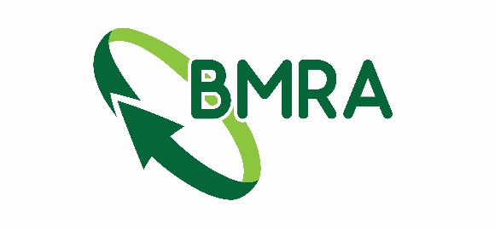

YBMR visit to Materials Processing Institute
Eston Rd, Middlesbrough TS6 6US
Tuesday 21 April 2026

FORM A
Company |  | Main Contact
Address |  | Tel no:
Address |  | Mobile:
Email
*Compulsory fields

Number of tickets required @ FREE

Please list all guest names on form B along with any special dietary needs.

FOR OFFICE USE ONLY
Numbers of Tickets sent:
Date:
Invoice Number:
Cheque Number:

YBMR visit to Materials Processing Institute
Eston Rd, Middlesbrough TS6 6US
Tuesday 21 April 2026

FORM B
PLEASE LIST CLEARLY IN BLOCK CAPITALS
SURNAME | FIRST NAME | COMPANY NAME | SPECIAL DIETARY REQUIREMENT  (please specify)

Please return completed forms to:
Cameron Leitch
BMRA
5 Ramsay Court, Hinchingbrooke Business Park
Huntingdon
Cambs
PE29 6FY
Tel: 01480 455249
Email: admin@recyclemetals.org

