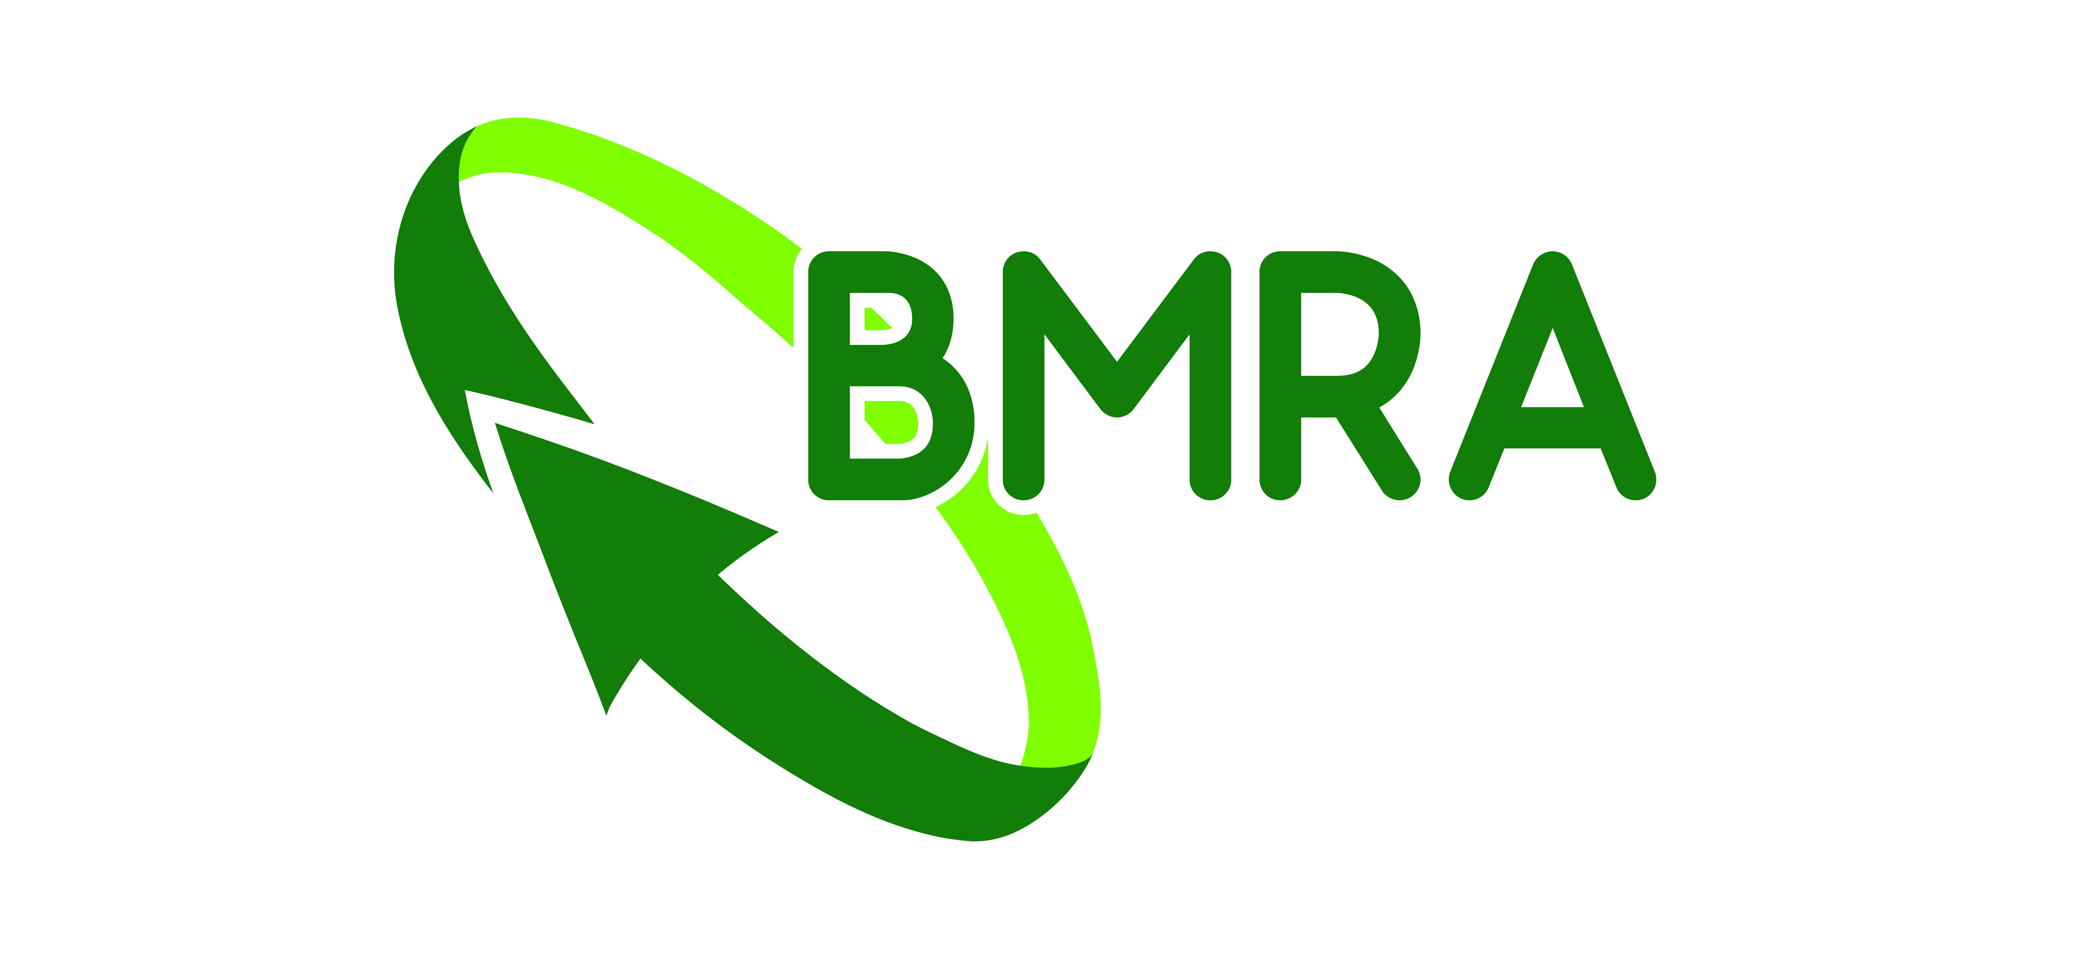

Job listing

Company | * |  | Contact | *
Tel no: |  | *
Email | *

Please provide as much of the below information as possible. Please also supply a company logo in a jpg format.

Listings will appear on the metal recycling jobs page on recyclemetals.org, via BMRA social media (Twitter, Facebook and LinkedIn), sent via an email, and via a link in FRAGments, BMRA’s monthly email newsletter.

Adverts are currently free of charge thanks to the generous sponsorship of International Metals & Cable Recycling.

Please note that it could take up to five working days or longer to post your listing.
Job title:
Company:
Location:
Hours:
Salary:
Overview of the company and role:
Key duties/responsibilities:
- XXXXXX
Skills required:
- XXXXX
Benefits include:
- XXXXXXX
FOR OFFICE USE ONLY
Date advert placed:
Date advert to be removed:
Invoice Number:
Closing date:
Contact:
Please return completed forms to: admin@recyclemetals.org

