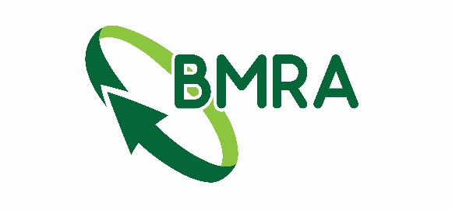

100 Year book order form
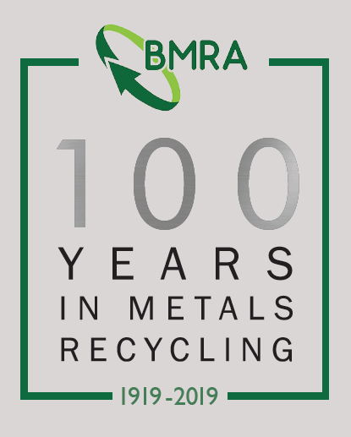
Additional copies of the ‘100 Years in Metals Recycling’ book are available to purchase at a cost of £30 including postage (UK only, international prices on request).

To order, fill in the below and send to

Invoices for the amount will be sent out. Payment may be required before dispatch.

Company |  |  | Contact
Address:
Email
Quantity of books required

Please return completed forms to:
admin@recyclemetals.org
FOR OFFICE USE ONLY
Date posted:
Invoice Number:

