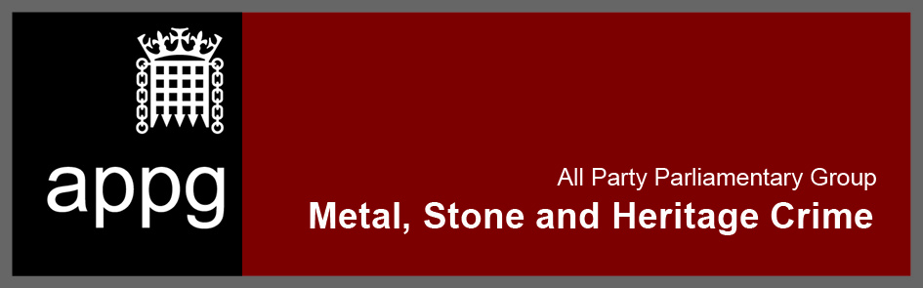
12 December 2018, 10am, Room C, 1 Parliament Street
Agenda

- Welcome and introduction
- Crime update (discussion)
  - Metal
  - Stone
  - Heritage
- Response to letter to Local Authorities
- Delay in release in ONS data: Property Crime including Metal Theft
- Online portals enabling crime
- Next steps

