Annual General Meeting
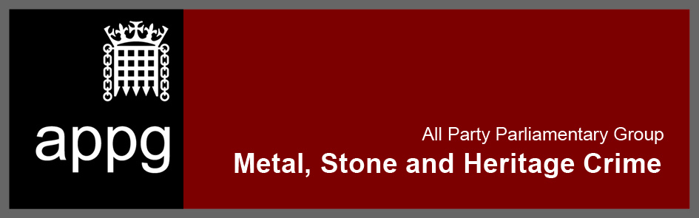
12 June, W2, Westminister Hall
Agenda

- Welcome and introduction
- Matters pertinent to the Annual General Meeting
  - Election of officers, currently:
    - Graham Jones (Chair)
    - Caroline Spelman (Secretary)
    - Nic Daikin (Treasurer)
    - Antonia Grey (Secretariat)
  - Review of income and expenditure in respect of the past reporting year
- Business of the Group:
  - Review of minutes and actions from the last meeting
  - Update on Metal crime issues and next steps
  - Update on Stone crime issues and next steps
  - Update on Heritage crime issues and next steps
- AOB

