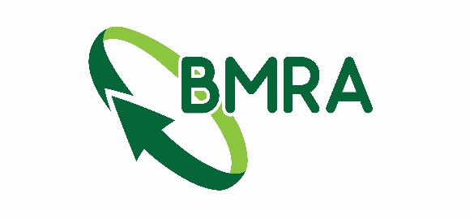

100 Year book order form
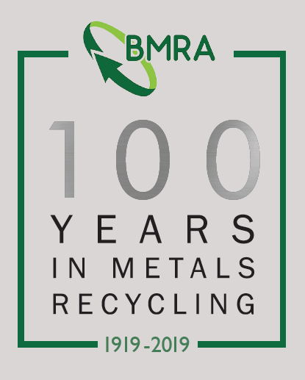
Additional copies of the ‘100 Years in Metals Recycling’ book are available to purchase at a cost of £30 including postage (UK only, international prices on request).

To order, fill in the below and send to admin@recyclemetals.org

Invoices for the amount will be sent out. Payment may be required before dispatch.

Company |  |  | Contact
Address:
Email
Quantity of books required

Please return completed forms to:
admin@recyclemetals.org
FOR OFFICE USE ONLY
Date posted:
Invoice Number:

